Mimecast Add-in Missing in Microsoft Outlook
Applies to: Classic Outlook for Windows • Mimecast for Outlook (COM add-in) • Software Center deployments
Most common fix: Confirm the user is in classic Outlook, then check whether Mimecast is inactive, disabled, or blocked as a slow COM add-in. Reinstall only when it is not registered or the earlier checks fail.

Purpose and scope
Use this article when the Mimecast tab or buttons are missing from Outlook. It replaces the original link-only troubleshooting step with the complete recovery workflow. This guide is for Outlook; it does not apply to Microsoft Word.
Important – new Outlook: Mimecast for Outlook is a COM add-in and does not run in the new Outlook for Windows or Outlook on the web. If the user is in new Outlook, switch to classic Outlook or use the Mimecast alternative approved by your organisation (for example, Mimecast Essentials or the Personal Portal).

Quick diagnosis
What you find | What it usually means | Go to
New Outlook / Outlook on the web | Classic COM add-ins are unsupported | Step 1 – switch client
Tray icon present; ribbon missing | Software may be running, but the Outlook add-in is not loaded | Steps 2–4
Listed as Inactive | Installed and registered, but unchecked/not loaded | Step 3
Listed as Disabled or Slow | Outlook disabled the add-in after a crash or performance event | Step 4
Not listed anywhere; no tray process | Installation or registration is missing/damaged | Steps 5–6

Resolution procedure
1. Confirm the Outlook client and start Outlook normally
- Use classic Outlook for Windows. If the user is in new Outlook, revert to classic Outlook before continuing.
- Do not test in Outlook Safe Mode. Safe Mode intentionally disables COM add-ins.
- Close Outlook completely, wait a few seconds, and open it normally.
2. Perform a quick ribbon and tray check
- In Outlook, check the ribbon for a Mimecast tab or Mimecast actions.
- In the Windows notification area, select the upward arrow (^) and look for the Mimecast icon.
- Treat the tray icon only as a clue: it can show that Mimecast software is running, but it does not prove that the Outlook COM add-in loaded.
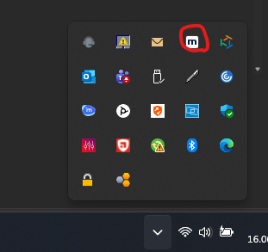
Figure 1. Mimecast icon in the Windows notification area (from the original KB).
3. Check whether Mimecast is Active, Inactive, Disabled, or missing
Outlook → File → Options → Add-ins
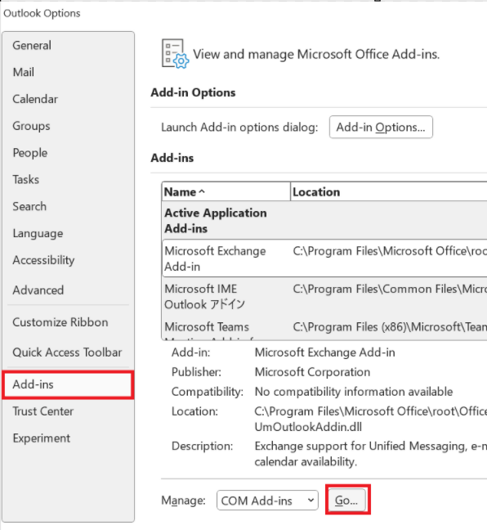
Figure 2. The Add-ins page and the Manage: COM Add-ins control. Source: Microsoft-hosted Outlook screenshot
- Active Application Add-ins: Mimecast is loaded. If the ribbon is still missing, close Outlook, confirm it is not in Safe Mode, and continue to Step 5.
- Inactive Application Add-ins: Mimecast is installed but not currently loaded. Continue with “Enable an inactive add-in” below.
- Disabled Application Add-ins: Outlook blocked the add-in. Continue with “Restore a disabled or slow add-in”.
- Not shown in any section: the add-in is probably not registered or installed. Go to Step 6.

Enable an inactive add-in
Manage: COM Add-ins → Go… → select “Mimecast for Outlook” → OK
- At the bottom of the Add-ins page, select COM Add-ins in the Manage list and select Go.
- Select the check box next to Mimecast for Outlook, then select OK.
- Close Outlook, wait at least five seconds, reopen it, and verify the ribbon.
4. Restore a disabled or slow add-in

If Mimecast is under Disabled Application Add-ins
Manage: Disabled Items → Go… → Mimecast → Enable
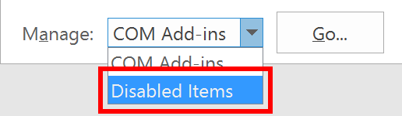
Figure 3. Use Disabled Items when Outlook has blocked an add-in. Source: TechHit troubleshooting guide
- Select Mimecast for Outlook and select Enable.
- Return to Manage: COM Add-ins, select Go, and make sure Mimecast for Outlook is checked.
- Restart Outlook and verify the ribbon.

If Outlook reports a slow or unhealthy add-in
Outlook → File → Slow and Disabled COM Add-ins
- Find Mimecast and select Always enable this add-in only if your support policy allows it.
- Restart Outlook. If Outlook repeatedly disables Mimecast or becomes unstable, do not keep forcing it on; continue to Step 5 and capture logs for escalation.
Performance caution: Outlook disables some COM add-ins after a crash or slow-load event. “Always enable” can restore functionality, but it can also reintroduce the original performance problem.
5. Restart the Mimecast process and reset the local cache (service desk / advanced)
- Close Outlook.
- Open Task Manager and confirm that msddsk.exe or Mimecast.Services.Windows.Personal is no longer running. End the process if required.
- Open %userprofile%\AppData\Roaming\Mimecast.
- Rename msw.s3db to msw.s3db.old. Renaming is safer than deleting and may require the user to authenticate again.
- Open classic Outlook and allow the Mimecast process to start again.
Older versions: The database may instead be under %ProgramFiles(x86)%\Mimecast\Mimecast Windows Service\data. If the expected path is missing, stop and escalate rather than modifying other files.
6. Repair by reinstalling from Software Center
- Close Outlook and stop the Mimecast process as described in Step 5.
- Open Control Panel → Programs → Programs and Features, then uninstall Mimecast for Outlook.
- Restart the computer.
- Sign in with an authorised administrator account if required by your environment.
- Open Software Center and install the approved Mimecast for Outlook package. Use the package that matches the organisation’s Office deployment.
- Restart when prompted, sign in as the affected user, open classic Outlook, and verify the Mimecast ribbon.

Verify the fix
- Mimecast is listed under Active Application Add-ins.
- The Mimecast tab or approved Mimecast buttons are visible in classic Outlook.
- Outlook opens normally and does not display a disabled/slow add-in warning.
- A normal Mimecast action available to the user completes without an error.
Resolved: The add-in remains active after Outlook is closed and reopened, and the user can access the required Mimecast function.

Escalate if the issue remains
Capture the following before escalating to the Microsoft 365 / messaging team or Mimecast Support:
- Whether the user is in classic Outlook or new Outlook.
- Outlook version and bitness, Windows version, and Mimecast for Outlook version.
- Where Mimecast appears after a fresh Outlook restart: Active, Inactive, Disabled, Slow and Disabled, or not listed.
- Screenshots of the Add-ins page and any warning or error.
- Mimecast logs from %ProgramData%\Mimecast\Logs.
- Whether the issue affects one user, one device, or multiple users/devices.

References
Mimecast for Outlook – Frequently Asked Questions — Official process, cache reset, reinstall, process names, and log location.
Mimecast for Outlook – Incompatibility with New Outlook — Official compatibility statement and supported alternatives.
Mimecast for Outlook – Prerequisites — Supported Outlook/installation conditions and new Outlook limitation.
Outlook add-in warnings — Microsoft guidance for slow, disabled, and unhealthy COM add-ins.
Mimecast missing on Outlook — Original linked COM Add-ins procedure.
How to fix a missing add-in in Outlook — Original inactive/disabled procedure and Figure 3 source.
Content verified against the linked sources on 25 August 2026.

